Class Diagram — API Gateway

CD Figure 1.4.1 – CD

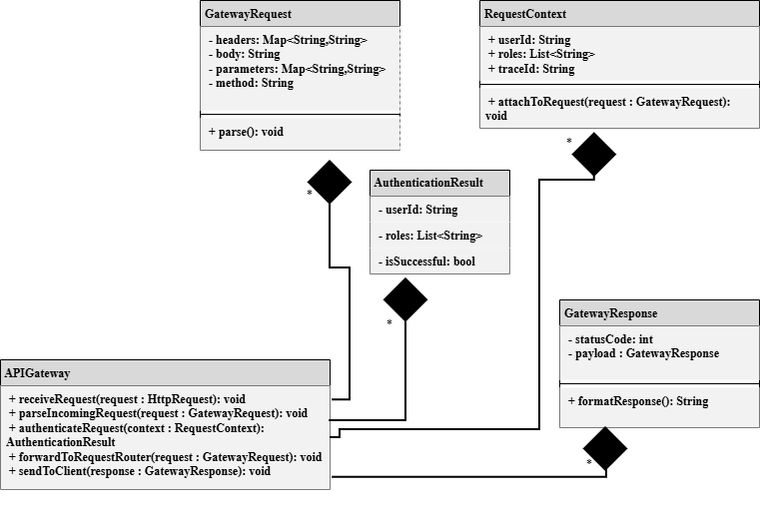

API Gateway Class Diagram View Design Information
Field | Description / Purpose
View Name & Number | 1.4.1-CD API Gateway Class Diagram View
Purpose / Design Concern | Manages User API Requests and verifies User Credentials
Description | Routes User API request results to either Authentication or back to the client for an appropriate gateway response.
Requirements
Elements
 | receiveGatewayRequest()
 | gatewayRequestObj
 | parseIncomingRequest()
 | RequestContext
 | authenticateRequest()
 | forwardToRequestRouter()
 | GatewayResponse
 | sendToClient()
 | formatResponse()
 | attachToRequest()
Inputs | Gateway Request
Outputs | Gateway Response, Request Context
Navigation / References | 1.4.2 Authentication Handler, 1.4.3 Request Router
Viewpoint | Class Diagram View

Class Diagram — Authentication Handler

CD Figure 1.4.2 - CD

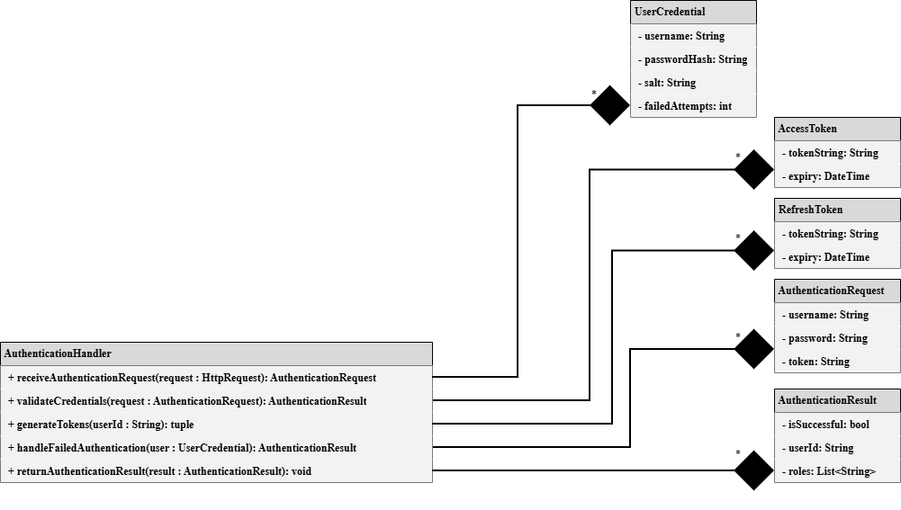

Authentication Handler Class Diagram View Design Information
Field | Description / Purpose
View Name & Number | 1.4.2-CD Authentication Handler Class Diagram View
Purpose / Design Concern | Verifies User Credentials and passes verification results to the API Gateway.
Description | Receives entered User Credentials and compares them to the users respective Credentials in an authentication database. Generates tokens upon successful verification. Returns results to the API Gateway
Requirements
Elements
 | receiveAuthenticationRequest()
 | AuthenticationRequest
 | validateCredentials()
 | AuthenticationResult
 | handleFailedAuthentication()
 | generateTokens()
 | returnAuthenticationResult()
 | AccessToken
 | RefreshToken
 | AuthenticationHandler
Inputs | Authentication Request
Outputs | AuthenticationResult
Navigation / References | 1.4.1 API Gateway
Viewpoint | Class Diagram View

Class Diagram — Request Router

SC Figure 1.4.3-CD

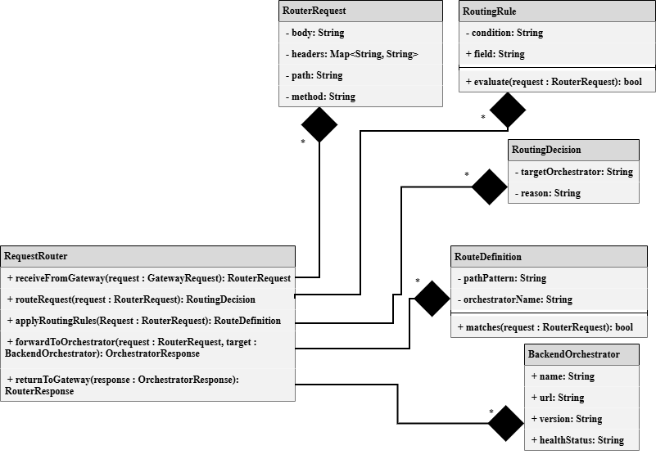

Request Router Class Diagram View Design Information
Field | Description / Purpose
View Name & Number | 1.4.3-CD Request Router Class Diagram View
Purpose / Design Concern | Receives Routing Requests and forwards them to their intended destination.
Description | Receives entered Routing Request and applies routing rules to the request’s Routing Definition. A Routing Decision is then made and the request is sent to its intended destination.
Requirements
Elements
 | receiveRouterRequest()
 | RouterRequest
 | applyRoutingRules()
 | RouteDefinition
 | handleRoutingErrors()
 | RoutingDecision
 | returnToGateway()
 | forwardToOrchestrator()
 | RequestRouter
 | BackendOrchestrator
Inputs | RouterRequest
Outputs | RoutingDecision, routerRequestObj
Navigation / References | 1.4.1 API Gateway, BackendOrchestrator
Viewpoint | Class Diagram View

